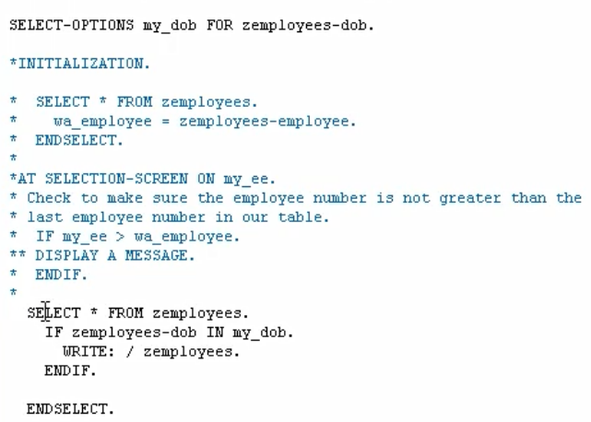



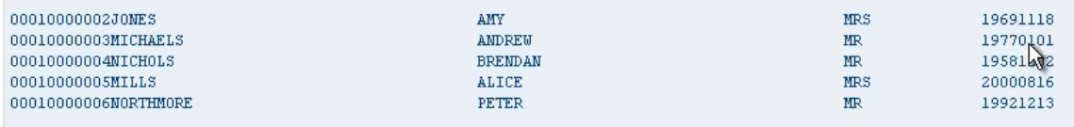

We will just write out the full record to the screen.

Well just by using this in operator, the system will take care of the selection for us, it will do all the work that is required to only return true if the employees date of birth doesn't meet the criteria set up in the internal table.